Name : Arshiya Tabassum A

Superset ID : 6424209

**WEEK 5**

**Creating Microservices for account and loan**

**AccountService**

**AccountApplication.java**

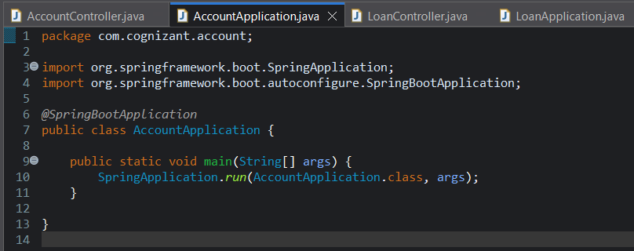

**AccountController.java**

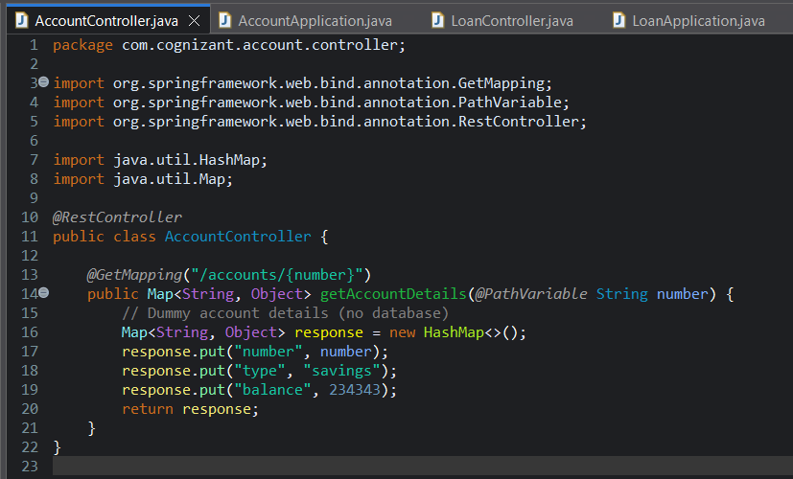

**Application.properties**

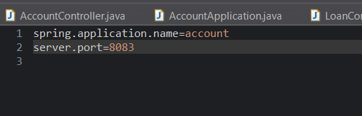

**Pom.xml**

<?xml version="1.0" encoding="UTF-8"?>

<project xmlns="http://maven.apache.org/POM/4.0.0" xmlns:xsi="http://www.w3.org/2001/XMLSchema-instance"

xsi:schemaLocation="http://maven.apache.org/POM/4.0.0 https://maven.apache.org/xsd/maven-4.0.0.xsd">

<modelVersion>4.0.0</modelVersion>

<parent>

<groupId>org.springframework.boot</groupId>

<artifactId>spring-boot-starter-parent</artifactId>

<version>3.5.3</version>

<relativePath/> <!-- lookup parent from repository -->

</parent>

<groupId>com.cognizant</groupId>

<artifactId>account</artifactId>

<version>0.0.1-SNAPSHOT</version>

<name>account</name>

<description>Demo project for Spring Boot</description>

<url/>

<licenses>

<license/>

</licenses>

<developers>

<developer/>

</developers>

<scm>

<connection/>

<developerConnection/>

<tag/>

<url/>

</scm>

<properties>

<java.version>21</java.version>

</properties>

<dependencies>

<dependency>

<groupId>org.springframework.boot</groupId>

<artifactId>spring-boot-starter-web</artifactId>

</dependency>

<dependency>

<groupId>org.springframework.boot</groupId>

<artifactId>spring-boot-devtools</artifactId>

<scope>runtime</scope>

<optional>true</optional>

</dependency>

<dependency>

<groupId>org.springframework.boot</groupId>

<artifactId>spring-boot-starter-test</artifactId>

<scope>test</scope>

</dependency>

</dependencies>

<build>

<plugins>

<plugin>

<groupId>org.springframework.boot</groupId>

<artifactId>spring-boot-maven-plugin</artifactId>

</plugin>

</plugins>

</build>

</project>

**Output :**

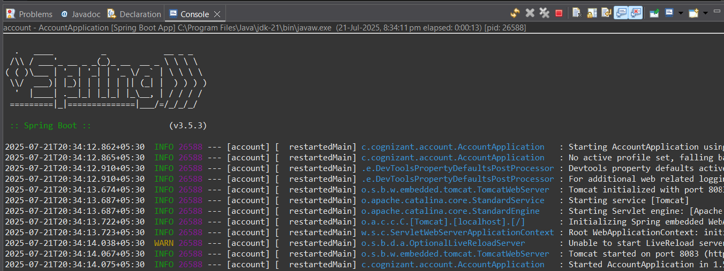

**Browser Test :**

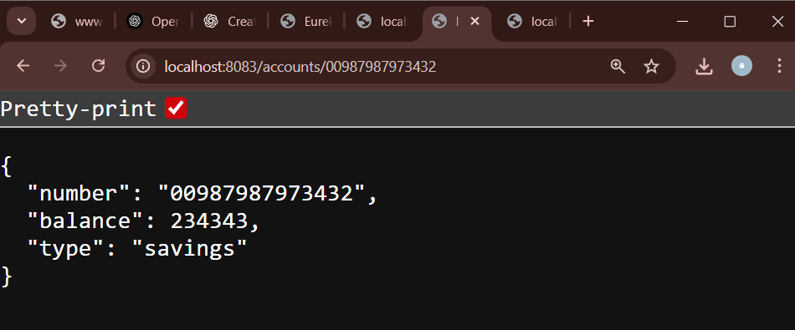

**LoanService**

**LoanApplication.java**

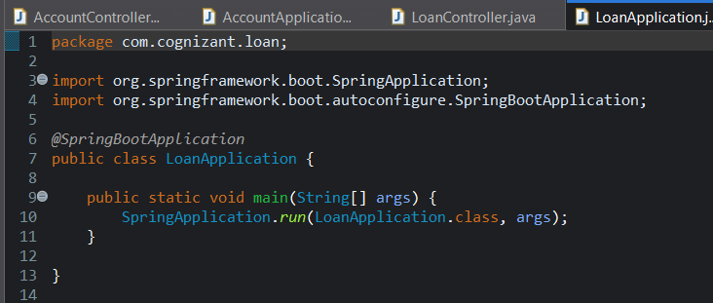

**LoanController.java**

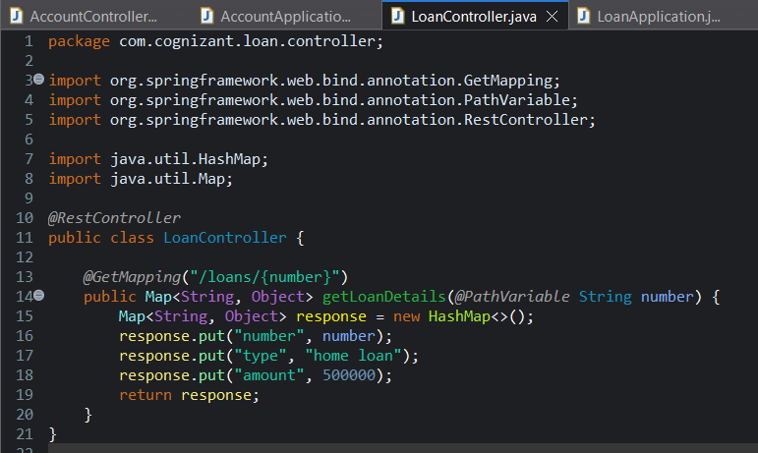

**application.properties :**

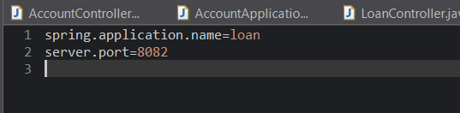

**Pom.xml**

<?xml version="1.0" encoding="UTF-8"?>

<project xmlns="http://maven.apache.org/POM/4.0.0" xmlns:xsi="http://www.w3.org/2001/XMLSchema-instance"

xsi:schemaLocation="http://maven.apache.org/POM/4.0.0 https://maven.apache.org/xsd/maven-4.0.0.xsd">

<modelVersion>4.0.0</modelVersion>

<parent>

<groupId>org.springframework.boot</groupId>

<artifactId>spring-boot-starter-parent</artifactId>

<version>3.5.3</version>

<relativePath/> <!-- lookup parent from repository -->

</parent>

<groupId>com.cognizant</groupId>

<artifactId>loan</artifactId>

<version>0.0.1-SNAPSHOT</version>

<name>loan</name>

<description>Demo project for Spring Boot</description>

<url/>

<licenses>

<license/>

</licenses>

<developers>

<developer/>

</developers>

<scm>

<connection/>

<developerConnection/>

<tag/>

<url/>

</scm>

<properties>

<java.version>21</java.version>

</properties>

<dependencies>

<dependency>

<groupId>org.springframework.boot</groupId>

<artifactId>spring-boot-starter-web</artifactId>

</dependency>

<dependency>

<groupId>org.springframework.boot</groupId>

<artifactId>spring-boot-devtools</artifactId>

<scope>runtime</scope>

<optional>true</optional>

</dependency>

<dependency>

<groupId>org.springframework.boot</groupId>

<artifactId>spring-boot-starter-test</artifactId>

<scope>test</scope>

</dependency>

</dependencies>

<build>

<plugins>

<plugin>

<groupId>org.springframework.boot</groupId>

<artifactId>spring-boot-maven-plugin</artifactId>

</plugin>

</plugins>

</build>

</project>

**Output :**

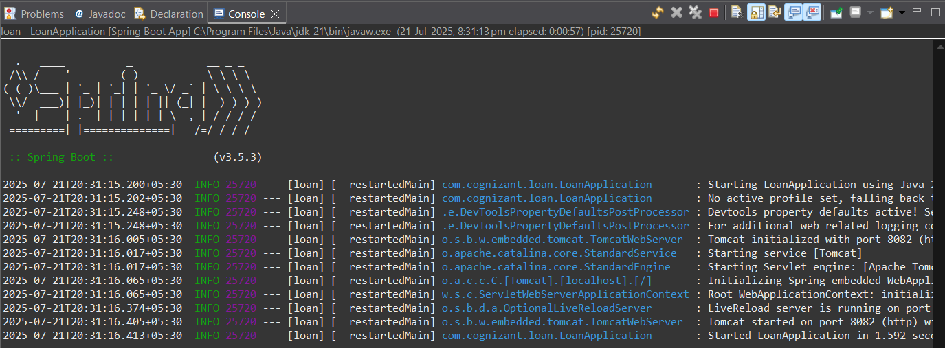

**Browser Test :**

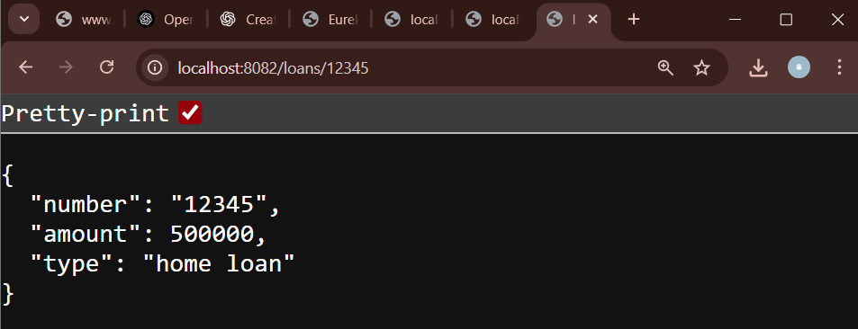

**Loan Microservice**

**LoanServiceApplication.java**

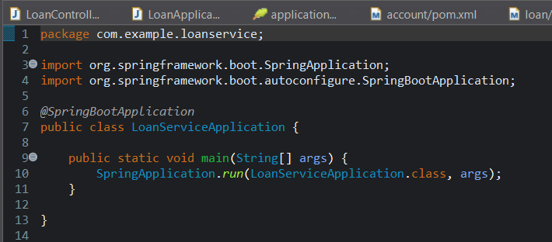

**LoanController.java**

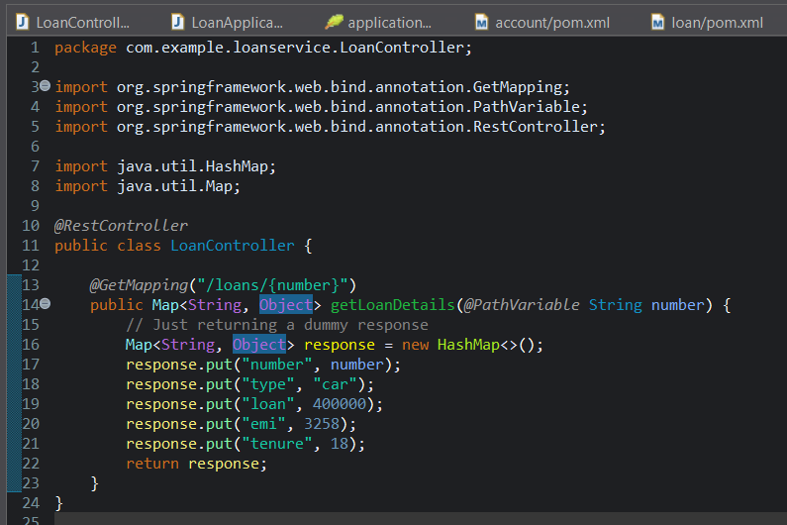

**application.properties**

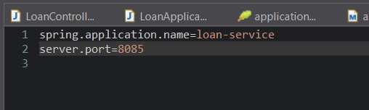

**Pom.xml**

<?xml version="1.0" encoding="UTF-8"?>

<project xmlns="http://maven.apache.org/POM/4.0.0" xmlns:xsi="http://www.w3.org/2001/XMLSchema-instance"

xsi:schemaLocation="http://maven.apache.org/POM/4.0.0 https://maven.apache.org/xsd/maven-4.0.0.xsd">

<modelVersion>4.0.0</modelVersion>

<parent>

<groupId>org.springframework.boot</groupId>

<artifactId>spring-boot-starter-parent</artifactId>

<version>3.5.3</version>

<relativePath/> <!-- lookup parent from repository -->

</parent>

<groupId>com.example</groupId>

<artifactId>loan-service</artifactId>

<version>0.0.1-SNAPSHOT</version>

<name>loan-service</name>

<description>Demo project for Spring Boot</description>

<url/>

<licenses>

<license/>

</licenses>

<developers>

<developer/>

</developers>

<scm>

<connection/>

<developerConnection/>

<tag/>

<url/>

</scm>

<properties>

<java.version>21</java.version>

</properties>

<dependencies>

<dependency>

<groupId>org.springframework.boot</groupId>

<artifactId>spring-boot-starter-web</artifactId>

</dependency>

<dependency>

<groupId>org.springframework.boot</groupId>

<artifactId>spring-boot-starter-test</artifactId>

<scope>test</scope>

</dependency>

</dependencies>

<build>

<plugins>

<plugin>

<groupId>org.springframework.boot</groupId>

<artifactId>spring-boot-maven-plugin</artifactId>

</plugin>

</plugins>

</build>

</project>

**Output :**

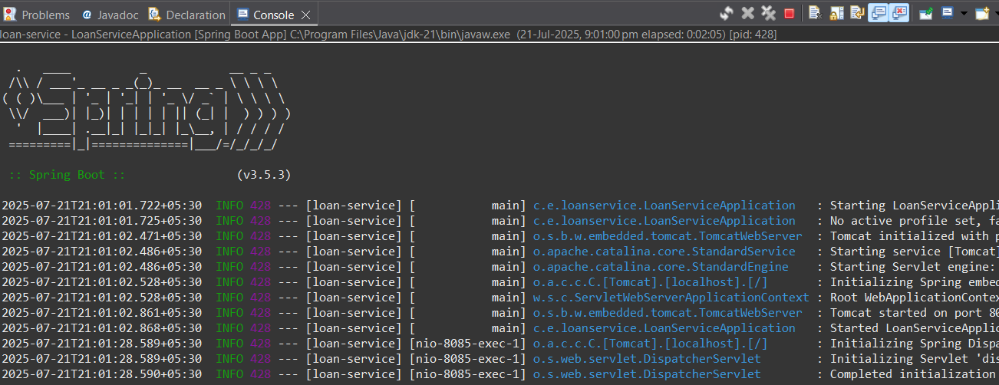

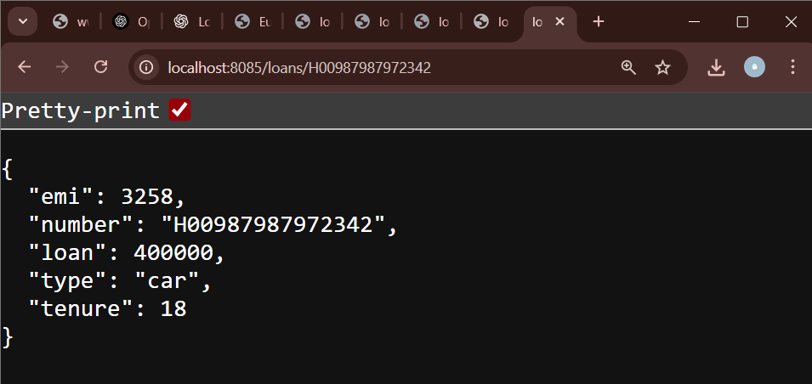

**Create Eureka Discovery Server and register microservices**

**EurekaDiscoveryServerApplication.java**

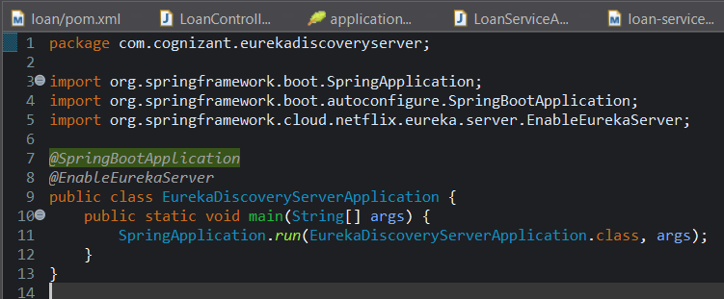

**Application.properties**

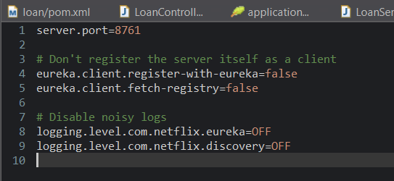

**Pom.xml**

c<?xml version="1.0" encoding="UTF-8"?>

<project xmlns="http://maven.apache.org/POM/4.0.0" xmlns:xsi="http://www.w3.org/2001/XMLSchema-instance"

xsi:schemaLocation="http://maven.apache.org/POM/4.0.0 https://maven.apache.org/xsd/maven-4.0.0.xsd">

<modelVersion>4.0.0</modelVersion>

<parent>

<groupId>org.springframework.boot</groupId>

<artifactId>spring-boot-starter-parent</artifactId>

<version>3.5.3</version>

<relativePath/> <!-- lookup parent from repository -->

</parent>

<groupId>com.cognizant</groupId>

<artifactId>eureka-discovery-server</artifactId>

<version>0.0.1-SNAPSHOT</version>

<name>eureka-discovery-server</name>

<description>Demo project for Spring Boot</description>

<url/>

<licenses>

<license/>

</licenses>

<developers>

<developer/>

</developers>

<scm>

<connection/>

<developerConnection/>

<tag/>

<url/>

</scm>

<properties>

<java.version>21</java.version>

<spring-cloud.version>2025.0.0</spring-cloud.version>

</properties>

<dependencies>

<dependency>

<groupId>org.springframework.cloud</groupId>

<artifactId>spring-cloud-starter-netflix-eureka-server</artifactId>

</dependency>

<dependency>

<groupId>org.springframework.boot</groupId>

<artifactId>spring-boot-starter-test</artifactId>

<scope>test</scope>

</dependency>

</dependencies>

<dependencyManagement>

<dependencies>

<dependency>

<groupId>org.springframework.cloud</groupId>

<artifactId>spring-cloud-dependencies</artifactId>

<version>${spring-cloud.version}</version>

<type>pom</type>

<scope>import</scope>

</dependency>

</dependencies>

</dependencyManagement>

<build>

<plugins>

<plugin>

<groupId>org.springframework.boot</groupId>

<artifactId>spring-boot-maven-plugin</artifactId>

</plugin>

</plugins>

</build>

</project>

**Output :**

